Project Management Essentials
Waterfall

Standard Operating Procedure
August 31, 2021

Table of Contents
1. Introduction 3
1.1. Purpose 3
1.2. Scope 3
2. PM Essentials Process for Waterfall 4
2.1. Project Characteristics 4
2.2. Initiation 5
2.3. Planning 5
2.4. Execution 6
2.5. Monitoring and Controlling 7
2.6. Project Closure 8
3. Roles and Responsibilities 8
4. Glossary and Acronyms 9
5. Feedback 10

Introduction

Purpose
PM Essentials (Project Management Essentials) is a project management process made up of tools and templates that empowers its users to be more efficient and effective in project delivery regardless of project size or complexity.
The Project Management Office (PMO) at DIR has created the PM Essentials process to help enable state and local entities to achieve their core missions through successful project delivery. Using these tools and templates can help your organization achieve project consistency, standardization, and project success. As PM Essentials is based on the Project Management Institute’s (PMI) Project Management Body of Knowledge (PMBOK) it employs industry-accepted standards of practice.
We note that for Texas state agencies, PM Essentials does not supersede the Texas Project Delivery Framework (TPDF) if projects meet the Major Project Criteria.

Scope
Anyone formulating and running a project can use these tools and templates. The PM Essentials process can be used to manage projects regardless of size, complexity, type, or methodology.

Template Name | File Format | Description/Purpose | Project Phase
Project Toolkit | .xlsx | The Project Toolkit is a comprehensive collection of templates for managing a project. Small, medium, and even large efforts, may be conducted with this file. | Planning, Execution, Monitor and Control

Bolded templates are the minimum recommended when using PM Essentials, regardless of project size or complexity.

Template Name | File Format | Description/Purpose | Project Phase
Business Case | .docx | The Business Case defines the business need along with the necessary information, from a business standpoint, to determine whether or not the project is worth the required investment. It demonstrates alignment to business and strategic objectives and is used to prioritize the project among other project demands. | Initiation
Charter | .docx | The Project Charter officially authorizes the project and allocates resources. The chartering process forms the project core team and officially kicks off the execution of a project. | Planning
Project Management Plan | .docx | The Project Management Plan defines "how" the project is executed, monitored and controlled, and closed. | Planning Execution,
Schedule | .mpp  -OR-  .xlsx | The Project Schedule is created to help plan and track important tasks and dates within the project. | Planning, Execution
Backlog | .xlsx | The Product Backlog, and its subset the Sprint Backlog, provides the scope of the development effort in an Agile framework. | Planning, Execution
Meeting Notes | .docx | The Project Meeting Notes Template is used to document and communicate notes for all project meetings. | Execution, Monitor and Control
Status Report | .docx | The Status Report is utilized for communicating the overall health of the project to the core team and key project stakeholders to keep everyone abreast of project progress. | Execution, Monitor and Control
Change Request | .docx | The Project Change Request (PCR) is used by the Project Manager to request a change to the project scope, schedule, costs, project milestones and/or deliverables. | Execution, Monitor and Control
Test Planning | .docx | The Test Plan is developed when the quality effort is large, complex, or requires coordination of testing elements (e.g. testers, environments, etc.). | Planning, Execution, Monitor and Control
Testing Scripting | .xlsx | The Test Script is developed to specify the steps taken by the tester in individual tests so that flaws can be replicated and addressed by the developer. | Planning, Execution, Monitor and Control
Transition Plan | .xlsx | The Transition Plan is developed to maximize the positive effect of a go-live event, and minimize the negative impacts. Readiness, cutover orchestration, communication, and rollback planning are included. | Planning, Execution, Monitor and Control
Lessons Learned | .docx | The Lessons Learned document is used to identify and preserve the lessons learned on each project. The purpose of this document is to help the project team share knowledge gained from the experience. A successful Lessons Learned program will help project teams repeat desirable outcomes and avoid undesirable outcomes, on future projects. | Closure
Project Closure | .docx | The Project Closure document formalizes the completion of the project. | Closure

PM Essentials Process for Waterfall

Project Characteristics
The PM Essentials Process has five core phases. The five phases represent a typical project lifecycle. They are initiation, planning, executing, monitoring and controlling, and closure. The waterfall methodology recognizes these phases such that each phase and sub-phase does not begin until the previous is completed. The diagram below identifies which PM Essentials templates are typically created and/or completed during each phase of the project.

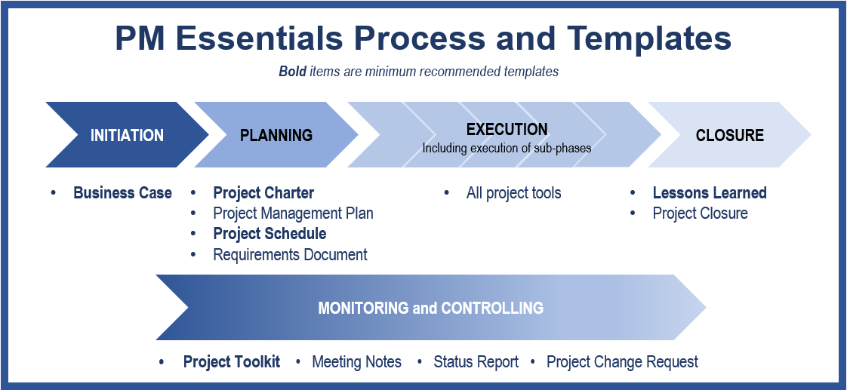

Initiation
The Initiation Phase reviews the business idea and commissions a formal project if the idea is approved.

Key Activities
- Identify the Business Issue to be addressed and/or opportunity to be leveraged
- Identify the benefits of doing the project, including financial impacts such as Return on Investment
- Define expected outcomes and key milestones
- Identify project risks and constraints
- Identify Key Stakeholders and required resources

Tools and Templates

Business Case
The Project Sponsor or Business Owner submits this template. This template will address the business issue and the expected business outcome as well as the key resources necessary for the project. It defines how the project will align to the goals of the agency and/or state.

Planning
The Planning Phase develops the approach and schedule for delivering the project. The priority on the triple constraint (scope, schedule, and cost) is finalized in the Planning Phase. The project team is formalized and the communications plan and project deliverables are identified.

Key Activities
- Finalize the project goals/scope
- Identify project/product requirements and project metrics and key performance indicators
- Develop the project schedule and high-level milestones
- Establish a cost plan (budget)
- Identify stakeholders and a communication plan
- Solidify the project team
- Develop a project plan to execute these actions
- Meet with Project Sponsor for approval to move forward with execution

Tools and Templates

Project Charter
The Project Charter defines the project scope, an estimated a timeline, and establishes a project budget. Once this document has been completed and approved, the Initiation Phase ends and the project moves into the Planning Phase.

Project Schedule
The Project Schedule Template is pre-configured to align to standard Project Management life cycle processes. There are two versions of the PM Essentials Project Schedule Template. One is a MS Project and the other an Excel spreadsheet. Pick the tool that works best for your project and organization. The project schedule allows you to plug in dates, resources, and budget information. Once populated with dates and resources, key performance indicators (KPIs) such as schedule variance and % complete, can then help track the project performance.

Requirements
This template provides a mechanism to track product/project deliverables against requirements to ensure business and product requirements are met.

(Optional) Project Management Plan
This template lays out a plan and strategy for “how” the project will be executed. The Project Charter defines the “what” while the Project Management Plan defines the “how”.

Execution
In the Execution Phase, the project plan is worked, the project deliverables are completed, and the project is implemented or “goes live.” The Execution Phase is where the work defined in the Project Charter is performed to satisfy the project objectives.

Key Activities
- Execute the project plan; tracking the project scheduled activities, expenditures issues/risks/action items, etc.
- Maintain project communications
- Manage quality of deliverables
- All project tools and templates should be used as appropriate to ensure on time project delivery

TOOLS and Templates
All PM Essentials tools and templates can be used during this phase.

Monitoring and Controlling
The Monitoring and Controlling Phase of the project is an overarching phase that commences in the Initiation Phase and extends through Project Closure. Templates included in the Monitoring and Controlling phase include reporting, tracking, and communication tools to ensure successful project delivery.

Key Activities
- Track project status
- Track and communicate project activities
- Monitor project health and status
- Measure/monitor and report project key performance indicators

TOOLS AND TEMPLATES

Project Toolkit
The Project Toolkit can be used to track action items, decisions, deliverables, risks, issues, stakeholder contact information, and more.

Meeting Notes
The Meeting Notes Template is meant to be utilized at all project meetings to document the meeting agenda, action items, decisions made in the meeting, who attended the meeting and scheduling the next meeting.

Status Report
The Status Report communicates key performance indicators (KPIs), key project dates, and key risks/issues related to the project in order to keep all project participants equally informed.

Project Change Request
Use this form to document major changes in the project that impact scope, schedule, costs, quality, or key project performance and health. This form should NOT be used to manage daily operational project management, project monitoring and control activities, as doing so will add significant overhead to the project management activities.

Project Closure
In the Project Closure Phase, the project artifacts are archived in the project repository, the project activities are completed, and the project transitions to operational status.

Key Activities
- Transition project to “operations”
- Archive project artifacts
- Document lessons learned and hold review meeting
- Plan a project post mortem
- Gain approval to formally close the project

TOOLS AND TEMPLATES

Lessons Learned
Populate the Lessons Learned document using Project Toolkit information and any other pertinent project artifacts, as well as project team feedback obtained from any lessons learned brainstorming.

Project Closure
The Project Closure Template documents confirmation that all in scope business objectives have been met and necessary project items have been finalized. This includes making sure all listed project deliverables have been completed and project documentation saved in suitable shared storage. This template also allows you to document how outstanding actions/issues are to be handled.

Roles and Responsibilities
Below are some typical roles found in a waterfall development effort.

Role | Responsibility
Project manager | Plans, directs, and monitors project activities performed by the team. Maintains communication with stakeholders.
Business owner | Communicates the business need and requirements to developers who are delivering the solution. Also responsible for sign off of deliverables (UAT)
Architect | Also known as technical architect, system architect, technical designer, and others. Assures the technical solution aligns with the goals, standards, and existing functionalities of the system.
Web designer | Develops the look-and-feel for browser-based applications.
Programmer | Writes the code that the solution executes to solve the business problem.
Database administrator | Provides database support for the solution being developed.
Business analyst | Liaison between the business and the technical sections to help identify the solution. May be involved with tool and requirements support.
Tester (unit, system, UAT) | Person(s) who validate that the solution works for the business. May be a product owner, business analyst, end users, developer, and/or project lead. Different testers are likely involved at different stages of the sprint.
Release manager | Provides the technical planning and coordination needed to deploy the solution.

Glossary and Acronyms

Business owner – person who communicates the requirements to the development team; ensures that the solution is relevant to the business problem.
Kickoff – the first meeting of a project; presents the business problem to be solved, an overview of goals, and description of team responsibilities.
KPI – key performance indicator, a metric or mark that gauges the performance of an activity usually to inform the health of an effort or project.
PCR – project change request, a mechanism to document and effect a significant change to project goals and objectives.
PMBOK – Project Management Body of Knowledge
Post-mortem – a post-project review, sometimes called lessons learned.
Project Manager – the person who plans, directs, and monitors the project for a successful outcome.
Requirements – a collection of business rules and specifications to be implemented in a product.
UAT – user acceptance testing
Waterfall – in contrast to an Agile model, a project methodology in which all of the features are rolled out in one release through a linear development process. Sometimes described as a “big bang” deployment.

Feedback
If you have any questions on PM Essentials or on project management practices, please contact DIR’s PPMO at ppmo@dir.texas.gov.

